Attention Waterfowlers

This is a reminder and notification that TUNDRA SWANS are present in the waters around Fort Belvoir at this time of year. Fort Belvoir does not fall in the TUNDRA SWAN hunt area which begins at Quantico Marine Base and extends south. Occasionally they are mistaken for SNOW GEESE. Please be mindful of this as SNOW GEESE are very uncommon in this area. There are significant differences which are mentioned below along with pictures for identification. Thank you for your cooperation!

TUNDRA SWAN
53” in length, black bill, all white, distinctive call
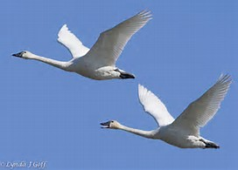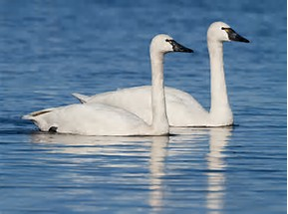

SNOW GOOSE
29” in length, black wing tips, pink bill
